

internship report

2019 June Batch



April 12, 2022

Student NAME: a g s p alahakoon

Student NUMBER: it19960432

Table of Contents

Introduction 2

1.1 Company Overview 2

1.2 Project Overview 2

1.3 Glossary 3

internship insight 4

1.4 Objectives 4

1.5 Procedures 4

1.6 Methodology 4

Learning outcome 5

1.7 Learning 5

1.8 Measurable Outcome 5

1.9 Effectiveness of the Effort 6

sample work 8

1.10 Imperial learning project 8

1.11 Study 365 blog main page 9

1.12 HRMS system 9

1.13 Globle Edulink – Privacy Policy page 11

# Introduction

## Company Overview

Global Edulink is a pioneer in online, classroom and live online education that reaches across thousands of learners both in and outside the UK. Our learning community receives the latest information and skills as well as tutor support from experts, around the clock customer assistance, course materials that are engaging and comprehensive and upon the successful completion of the course, an accredited certification from esteemed awarding bodies. Our subject areas are diverse including accounting and finances, animal care, business and management, employability skills, hospitality, travel and tourism, health & social care, information technology, HR & leadership, general maths & statistics, office administration & reception, project management, sales & marketing, science, engineering & logistics, teaching and education and more. Our awarding bodies include, Pearson BTEC, NCFE CACHE, NEBOSH, ATHE, CMI, CIMA, ABC Awards, Axelos, Sage, CPD, iAP, Chartered Institute of Environmental Health and more. Global Edulink pays attention to the highest standards in education. Our online courses are consistent with all the right standards that the awarding bodies require and the course material is accessible at any time for the learner. Students also have the luxury of studying from anywhere they wish to. Live Online classes are conducted online but in real time where students can engage with the tutor and other students. Learners also get free access to the online version of the course when they enrol in Live Online. Our classroom courses are all about creating a real classroom experience. The programmes last for a very short duration but are highly intensive and thorough.

My working department is IT department under this company. In our department we have to develop and maintain 17 sub brands as 17 websites. Global Edulink is on of our major brands.

## Project Overview

All our projects are based on the PHP Laravel framework, the React library, HTML, CSS, JavaScript, PHP, Bootstraps, and jQuery.

**GEL Free resources projects** were given as the first project. In this project, interns have to use the PHP Laravel framework to implement the backend of the system. Interns are allowed to use the Blade template engine or any other front-end framework to implement the front-end of the system. This was a self-learning project. Interns had to refer to documentation and tutorials before implementing the system because we did not have any previous experience with the Laravel framework. In this project, we had to use the passport authentication system, Laravel email functions, and also, they had to implement all CRUD operations.

After the GEL Free resources project, interns were assigned to the **Study365 project**. In this project, we had to implement some front-ends according to the provided design. For the implementation, we had to use HTML, CSS, JavaScript, Bootstrap, and jQuery. We had to implement those front ends as mobile responsive.

After the Study 365 project, interns were assigned to the **HRMS project**. This system was developed for the HR department of our company. In this project, we had to use Laravel for the backend API implementation and React for the front-end implementation. SQL was used as a database.

After finishing some modules in the HRMS project, they gave us **Study 365 landing pages** to study. Here we did only front-end development using HTML, CSS, Bootstrap, JavaScript, and PHP. The backend of these pages is run through the WordPress platform. Here I have developed a blog main page and a blog details page.

Then they gave me an **Imperial Learning web project** for me. Imperial Learning is the mother company of the global education company. Global edulink is a product of the Imperial Learning Company. So I had to develop the whole website. This whole project was done by me. This project does not have a back-end part. For the front-end part, I have used HTML, PHP, Bootstrap, CSS, SCSS, SendGrid, and JavaScript. For now, this site only has a demo version on the internet because it is still under QA level.

## Glossary

Following are the abbreviations and definitions used in this document.

|  |  |
| --- | --- |
| **Abbreviation** | **Description** |
| HTML | Hyper Text Mark-up Language |
| PHP | Hypertext Pre-processor |
| CSS | Cascading Style Sheets |
| SCSS | Sassy Cascading Style Sheets |
| QA | Quality Assurance Engineer |
| HRMS | Human Resource Management System |
| PR | Private Repository. |

# internship insight

## Objectives

I wanted to gain industry experience as well as improve my soft skills as an undergraduate. I also intended to assure my improvement by confronting the issues that arose during the growth process. I needed to gain practical experience managing projects and sprints. In addition, I concentrated  as a full stack developer, to increase my development abilities As a result, I read a lot of paperwork and  I took some online courses on a variety of topics. Aside from my internship assignments, I've worked on a number of other things.  During the internship, I worked on multiple self-learning projects in several programming languages. The company's goal is to give a better and uninterrupted service to their students. They seek to increase their profit margins by giving better service to the interns.

## Procedures

1. Daily Scrum meetings were held from 2:00 PM to 2:30 PM Monday through Friday to provide an update on the daily tasks we were working on.
2. Every Monday and Friday from 6:00 p.m. to 7:00 p.m., a stand-up meeting was held. We had to give an update on work they had finished and explain challenges that developers had to deal with during this meeting.
3. Jira is used to manage projects. The version control system utilized was Bitbucket.
4. We were given Jira projects to work on, and we had to update the Jira dashboard in accordance with the job.
5. When quality assurance engineers discover an issue, they generate a Jira ticket, and we are assigned to the Jira tickets.
6. When working on tasks in Jira, we had to build different branches for each ticket number we were working on.
7. The TeamWork application was used by all teams to interact. For each team, there were distinct channels.
8. Working Time
   1. March – October 12:30 PM to 9:30 PM (SL Time)
   2. October – March 1:30 PM to 10:30PM (SL Time)
9. Hours – 9 hours per day (with 1 hour meal time).
10. Working Days – Weekdays

## Methodology

On interfaces, the UI/UX Engineers cooperate with the company's development team. The UI/UX team created responsive interface designs. Figma was used to share their creations. We were able to swiftly develop the front end according to the supplied Figma design by the UI/UX Engineers, as well as implement backend functionalities according to the specifications, by looking at their demands. On the other hand, they provide particular recommendations to us.

To keep track of all system versions, a private Bitbucket organization was used. For each system, the company maintains different repositories. I worked on the repositories of, Imperial Learning, Study365, and HRMS. When implementing a feature, we must establish a new branch based on the Jira ticket number. We committed and generated a PR after the implementation. The team leader should be designated as a reviewer when we create PR. The team leader looks through our PRs and merges them.

During the internship term, Jira was utilized for project management. QAs write a Jira ticket and assign it to us when they detect an issue. When we are correcting the defects, we need to build a different branch based on the Jira ticket number. We must move the Jira ticket to the 'On Progress' column in the Jira dashboard when we are correcting problems. We move the Jira ticket to the QA column and designate the QA who created the ticket when we conclude problem fixes.

# Learning outcome

## Learning

During the internship, I strengthened both my technical and soft abilities. As far as front end technologies go, I utilize HTML, CSS, JavaScript, Bootstrap, jQuery, and the React framework. The PHP Laravel framework was utilized to create backend features throughout the internship.

The internship allowed me to develop my programming abilities. I gained and improved my understanding of the PHP Laravel framework. The Laravel framework was completely unfamiliar to me when I began my internship. I've never used the Laravel framework before. As a result, I had to study a lot of material and take various Laravel framework online classes. I've also completed some self-study projects using the Laravel framework. (https://github.com/ShalithaAlahakoon/freeResources.git)

Also I learned about below topics

* Mobile responsiveness
* How to work within the given dead line
* Teamwork
* How deploy website
* How to measure product quality using QA
* React learning
* Word press
* Java script usage
* Professional life
* Agile development

## Measurable Outcome

* **Enhance my programming abilities.**

The PHP Laravel framework is the primary emphasis of this firm. The Laravel framework was used in the majority of their projects. Laravel was new to me when I started my internship. As a result, I had to learn Laravel from the ground up. I had to study the documentation for Laravel as well as some online courses. Aside from, I needed to brush up on my PHP skills. The react library is used for front end implementations in addition to Laravel. I had some prior knowledge with React library before I started the internship. This internship allowed me to increase my response knowledge. I had some prior knowledge with React library before I started the internship.

This internship allowed me to increase my react knowledge. In addition, I was able to expand my bug-fixing knowledge. I learned how to read bugs and how to solve problems with them. When it comes to problem repair, there are various strategies we should utilize, such as using log statements and reviewing previously written code to grasp the reasoning.

We didn't pay much attention to file structures, coding practices, or design patterns when we were in college. However, we cannot overlook the sector's requirements. I had to uphold those standards from the beginning as a full-stack engineer. It was necessary to handle exceptions and do unit testing. All of the standards and best practices have to be understood.

We can utilize Stack Overflow or YouTube to resolve problems in academic tasks. In industry projects, however, we have more complex customer requirements. As a result, YouTube and Stack Overflow answers cannot be used to solve certain challenging problems. The best answers to such problems may only be found by properly reading the material and grasping the ideas.

* **New programming languages, frameworks, and technologies were discovered**.

The Jira project management application is used to handle projects in this organization. When I first started at this organization, I had no prior expertise with Jira dashboard. I was able to gain a lot of knowledge about Jira.

* **Improve my interpersonal skills**

• I was able to develop my communication skills

• I became a competent team player

• I became familiar with office work culture

## Effectiveness of the Effort

My internship began in the first semester of my third year. I had a lot of theoretical knowledge about what I had learned in the previous two years when I started my internship. I was well-versed in functional programming, object-oriented programming, data structures and algorithms, web development using a variety of programming and scripting languages, and database administration, both relational and non-relational.

I didn't know how to use my academic expertise in the workplace while having a lot of theoretical understanding. We must observe some industrial principles in the industrial environment. In addition, the majority of businesses have their own set of rules. As a result, we must use our academic understanding in accordance with their rules.

I utilized the PHP Laravel framework during my internship. This framework is based on PHP's object-oriented programming language.

As a result, I had to employ my object-oriented programming skills. All of the object-oriented concepts that I learned in my second year have to be applied. Additionally, SQL was utilized to administer the database. As a result, I had to apply every database idea I had studied in my first and second years. I had to apply every topic from the IWT module that I had learned in the first year.

Aside from theoretical knowledge, additional modules such as Employability Skills Development and professional skills were extremely beneficial in helping us to thrive in the workplace.

# sample work

## Imperial learning project

This whole Project is developed by me

URL: - [Imperial Learning](http://demo.imperiallearning.co.uk/shalitha/)

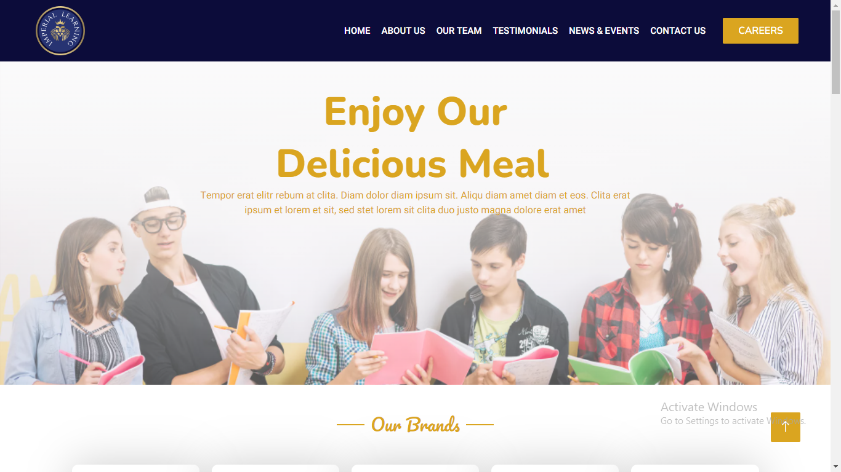

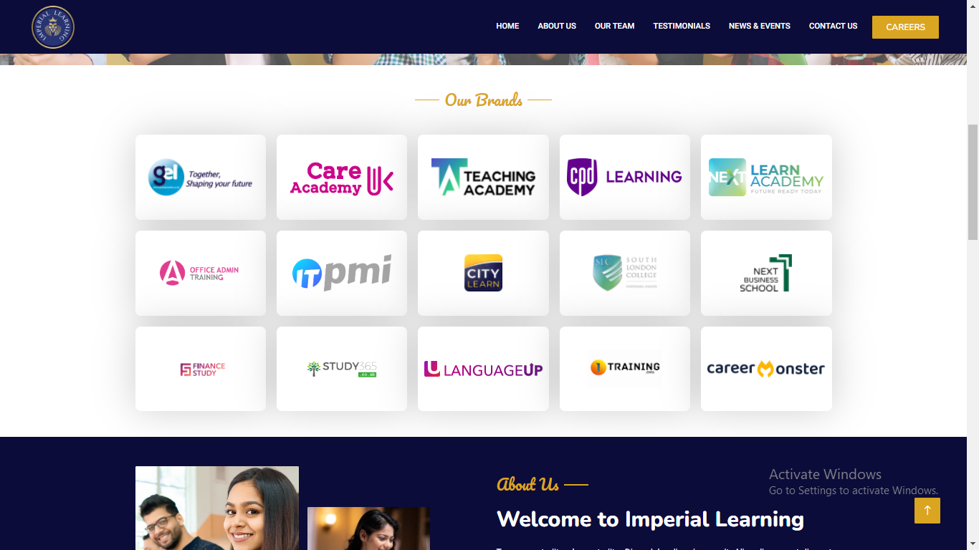

## Study 365 blog main page

URL: - [Blog - Study 365](https://www.study365.co.uk/blog/)

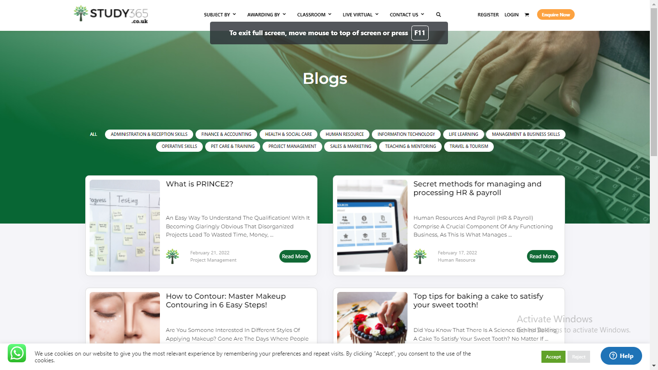

## HRMS system

Here I have developed 3 modues colled Designations, Countries and Leave types with all crud operations

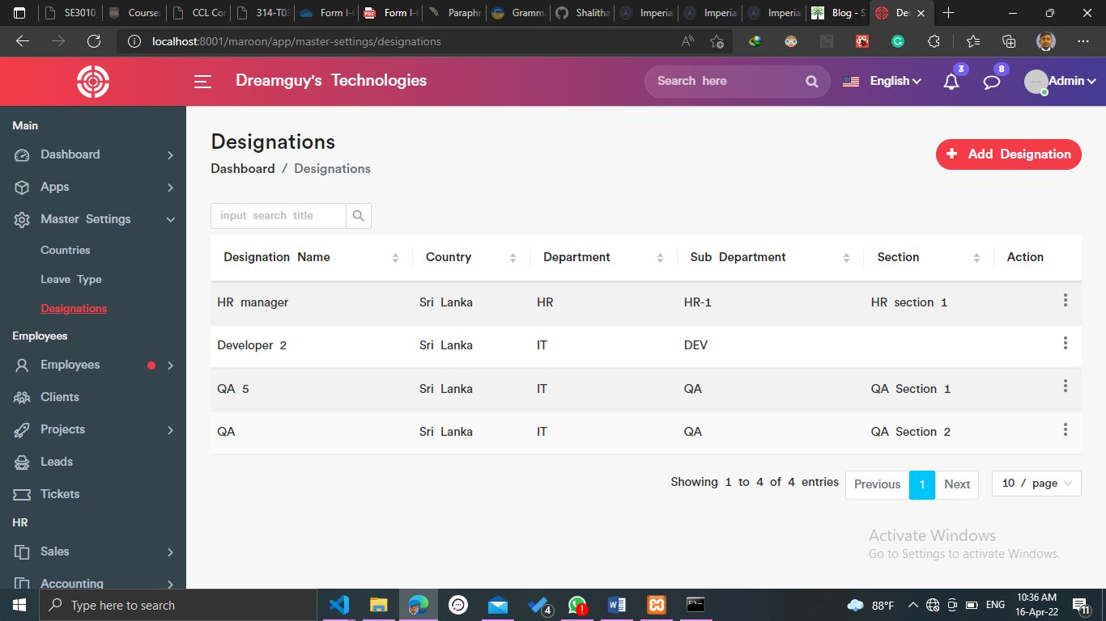 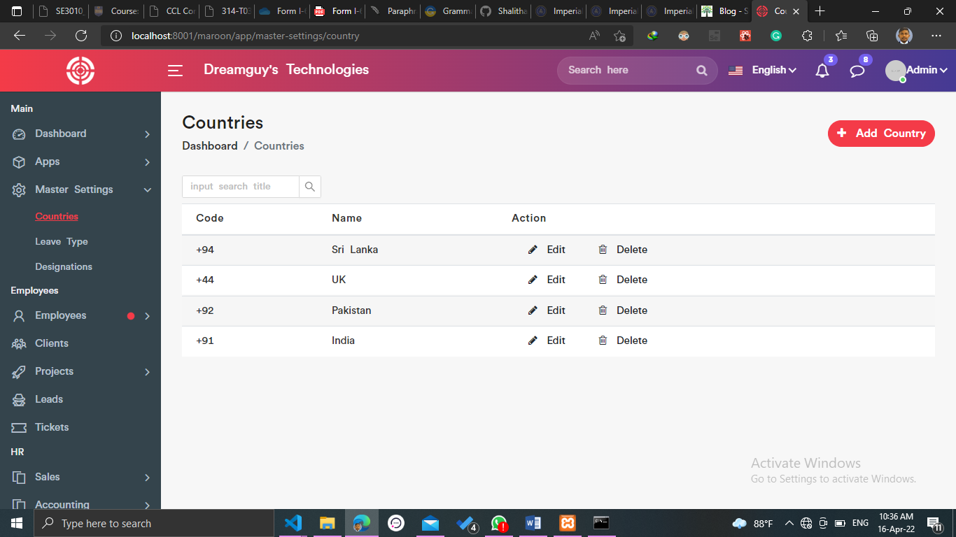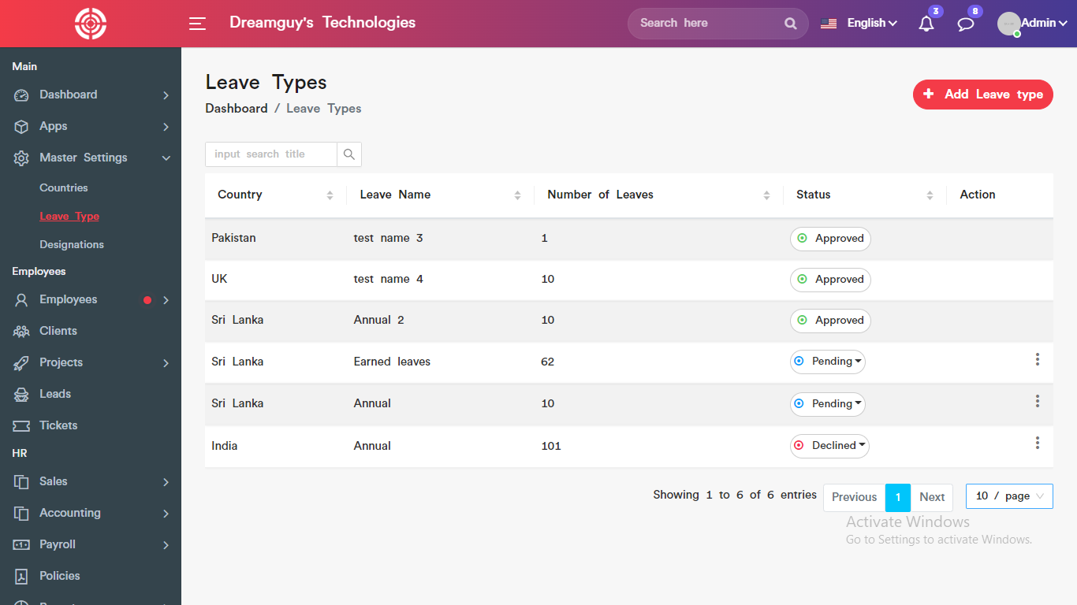

## Globle Edulink – Privacy Policy page

Page URL :- [Privacy Policy - Global Edulink](https://www.globaledulink.co.uk/privacy-policy/)

